**Proof of Theorem :-**

**Existence of a rearrangement that sums to any positive real M**

For simplicity, this proof assumes that an ≠ 0 for every n. We define an+ and an- by :





Since is conditionally convergent, both the series and diverge.

Let M be a positive real number. Take, in order, just enough positive terms an+{\displaystyle a_{n}^{+}} so that their sum exceeds M. Suppose we require *p* terms, then the following statement is true:



This is possible for any M > 0 because the partial sums of an+{\displaystyle a_{n}^{+}} {\displaystyle a_{n}^{+}} tend to +∞{\displaystyle +\infty } Discarding the zero terms one may write

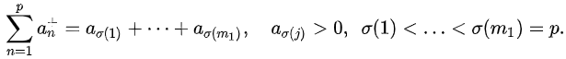

Now we add just enough negative terms an-, say q of them, so that the resulting sum is less than M. This is always possible because the partial sums of an- tend to -∞. Now we have:

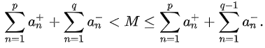

Again, one may write

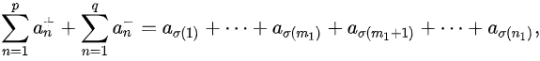

with



The map *σ* is injective, and 1 belongs to the range of *σ*, either as image of 1 (if *a*1 > 0), or as image of *m* 1 + 1 (if *a*1 < 0). Now repeat the process of adding just enough positive terms to exceed M, starting with *n* = *p* + 1, and then adding just enough negative terms to be less than M, starting with *n* = *q* + 1. Extend *σ* in an injective manner, in order to cover all terms selected so far, and observe that a2 must have been selected now or before, thus 2 belongs to the range of this extension. The process will have infinitely many such **"*changes of direction*".** One eventually obtains a rearrangement  ∑ aσ(n). After the first change of direction, each partial sum of  ∑ aσ(n) differs from M by at most the absolute value apj+ {\displaystyle a_{p_{j}}^{+}}or |aqj-|{\displaystyle |a_{q_{j}}^{-}|} of the term that appeared at the latest change of direction. But ∑ an converges, so as n tends to infinity, each of an, {\displaystyle a_{p_{j}}^{+}}apj+ and aqj-{\displaystyle |a_{q_{j}}^{-}|}{\displaystyle a_{q_{j}}^{-}} go to 0. Thus, the partial sums of  ∑ aσ(n) tend to M, so the following is true:

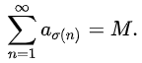{\displaystyle \sum _{n=1}^{\infty }a_{\sigma (n)}=M.}

The same method can be used to show convergence to *M* negative or zero.

**Existence of a rearrangement that diverges to infinity**



Let be a conditionally convergent series. Let {\displaystyle p_{1}<p_{2}<p_{3}<\cdots }p1 < p2 < p3 < …. be the sequence of

indexes such that each {\displaystyle a_{p_{i}}}api is positive, and define  {\displaystyle p_{1}<p_{2}<p_{3}<\cdots }n1 < n2 < n3 < …. {\displaystyle n_{1}<n_{2}<n_{3}<\cdots } to be the indexes such that each {\displaystyle a_{n_{i}}}ani is negative (again assuming that {\displaystyle a_{i}}ai is never 0).

Each natural number will appear in exactly one of the sequences ({\displaystyle (p_{i})}pi) and (ni).{\displaystyle (n_{i}).}

Let {\displaystyle b_{1}}b1 be the smallest natural number such that

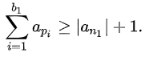{\displaystyle \textstyle \sum _{i=1}^{\infty }a_{i}}

Such a value must exist since (api) the subsequence of positive terms of (ai) diverges. Similarly, let b2 be the smallest natural number such that:

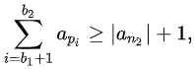

and so on, this leads to the permutation :



And the rearranged series, then diverges to ∞.

Similarly -∞ can also be attained.

**Existence of a rearrangement that fails to approach any limit, finite or infinite**



In fact, if is conditionally convergent, then there is a rearrangement of it such that

the partial sums of the rearranged series form a dense subset of R.